**NANDHA COLLEGE OF TECHNOLOGY**

**ERODE- 638 052**



**DEPARTMENT OF INFORMATION TECHNOLOGY**

**CS3492–DATABASE MANAGEMENT SYSTEMS**

(Regulations 2021)

**FOURTH SEMESTER**

(ACADEMIC YEAR 2022-23)

***ASSIGNMENT / CASE STUDY REPORT – I***

**ER DIAGRAM PROBLEMS**

|  |  |
| --- | --- |
| **REGISTER NUMBER** | **732121205016** |
| **NAME OF THE STUDENT** | **C.K.DHARUN** |
| **SUBMITTED ON** |  |
| **MARKS OBTAINED** |  |
| **STAFF SIGN WITH DATE** |  |

ER DIAGRAM PROBLEMS

**CONTENT:**

1. **INTRODUCTION**
2. **ER - DIAGRAM NAME & SYMBOLS**
3. **PROBLEM 1**
4. **SOLUTION**
5. **PROBLEM 2**
6. **SOLUTION**
7. **CONCLUSION**

**1.INTRODUCTION:**

ER diagrams are crucial tools in database design, particularly for complex systemsAn Entity-Relationship (ER) diagram is a type of visual representation used to model the structure of a database or information system. ER diagrams are often used in the early stages of system design to help identify the entities and relationships involved in the system, and to provide a high-level overview of how data will be organized and accessed.

ER model stands for an Entity-Relationship model. It is a high-level data model. This model is used to define the data elements and relationship for a specified system.

It develops a conceptual design for the database. It also develops a very simple and easy to design view of data.

In ER modeling, the database structure is portrayed as a diagram called an entity-relationship diagram.

**2.ER - DIAGRAM NAME & SYMBOLS:**

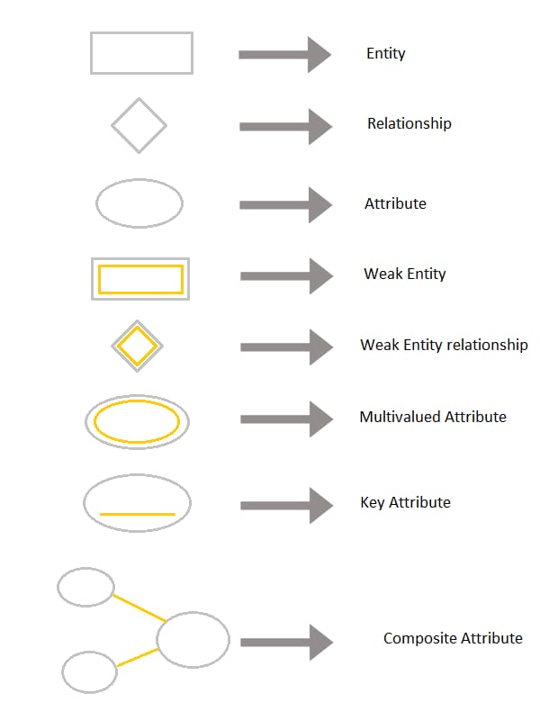

**3.PROBLEM 1:**

Construct an ER diagram for Hospital Management System

**PROBLEM 1 REQUIREMENTS:**

The hospital management system has the following requirements:

The system should store the personal and medical information of patients, such as their name, address, date of birth, medical history, and current medications.

* The system should store information about doctors and staff, including their name, contact details, and work schedule.
* The system should keep track of the medical facilities available in the hospital, such as wards, rooms, and equipment.
* The system should track patient appointments, including appointment times, doctor details, and reason for visit.
* The system should allow doctors to prescribe medication to patients and maintain a record of the medication prescribed.

Based on these requirements, we can create an ER diagram that represents the relationships between the entities in the system. The diagram will have the following entities:

* Patient: This entity will store information about the patients, such as their personal and medical information.
* Doctor: This entity will store information about the doctors, including their name and contact details.
* Staff: This entity will store information about the hospital staff, such as their name, contact details, and work schedule.
* Facility: This entity will store information about the medical facilities available in the hospital, such as wards, rooms, and equipment.
* Appointment: This entity will store information about patient appointments, including appointment times, doctor details, and reason for visit.
* Prescription: This entity will store information about the medication prescribed by doctors to patients.

The ER diagram will also include the following relationships:

* One patient can have multiple appointments, but each appointment is with only one doctor.
* Each doctor can have multiple appointments with different patients.
* One patient can have multiple prescriptions, but each prescription is from only one doctor.
* Each doctor can prescribe medication to multiple patients.
* The hospital staff can work in multiple facilities, and each facility can have multiple staff members



**4.SOLUTION :**

Medical Report

Doctor

has

has

Hospital

Patient

Admitted in

**5.PROBLEM 2:**

Construct an ER Diagram for Railway Reservation.

**PROBLEM 2 REQUIREMENT:**

The railway reservation system has the following requirements:

* The system should store information about the trains, including their train number, route, and schedule.
* The system should store information about the passengers, including their name, address, and contact details.
* The system should track reservations, including the train number, passenger details, and seat information.
* The system should keep track of the train's availability, including the number of seats available for each train.
* The system should generate reports such as train schedules, reservation details, and passenger information.

Based on these requirements, we can create an ER diagram that represents the relationships between the entities in the system. The diagram will have the following entities:

* Train: This entity will store information about the trains, including their train number, route, and schedule.
* Passenger: This entity will store information about the passengers, including their name, address, and contact details.
* Reservation: This entity will store information about the reservations, including the train number, passenger details, and seat information.
* Seat: This entity will store information about the seats available on the train.
* Route: This entity will store information about the routes that the trains follow

The ER diagram will also include the following relationships:

* Each train can have multiple routes, but each route is for only one train.
* Each train can have multiple seats, but each seat is on only one train.
* Each reservation is for only one train and one passenger.
* Each passenger can have multiple reservations, but each reservation is for only one passenger.



**6.Solution:**

Issue

Ticket

Passenger

Done

Checks

payment

Manage

Technical Supervisor

Train Details

**9.CONCLUSION:**

In conclusion, ER diagrams are essential tools in database design, particularly for complex systems. They help to visualize the relationships between entities in a database and how those entities interact with each other. By identifying and representing the relationships between entities, ER diagrams can help developers optimize queries, ensure data integrity, and develop and maintain systems more efficiently.

****In the case studies discussed, we saw how ER diagrams can be used to represent the relationships between entities in different systems, such as a hospital management system and a railway reservation system. The ER diagrams effectively represented the entities and their relationships, making it easier to develop and maintain the systems